Table of contents
Overview 1
Online claim lodgement 2
Claims that have not been lodged section 3
Claims(s) being processed section 3
Claim stages and claim status 5
Claims history section 5
Benefit requests section 6
Other functions 6

Overview
From the Claims screen you can lodge a claim form for:
- initial liability under each of the acts (VEA, SRCA, MRCA)
- compensation following death under each of the acts (VEA, SRCA, MRCA)
- determining qualifying service
- pensions
- cards.
From this screen you can also open draft claims and view the status of claims lodged with the department within the last three years.

The Claims and Benefits requests screen displays.
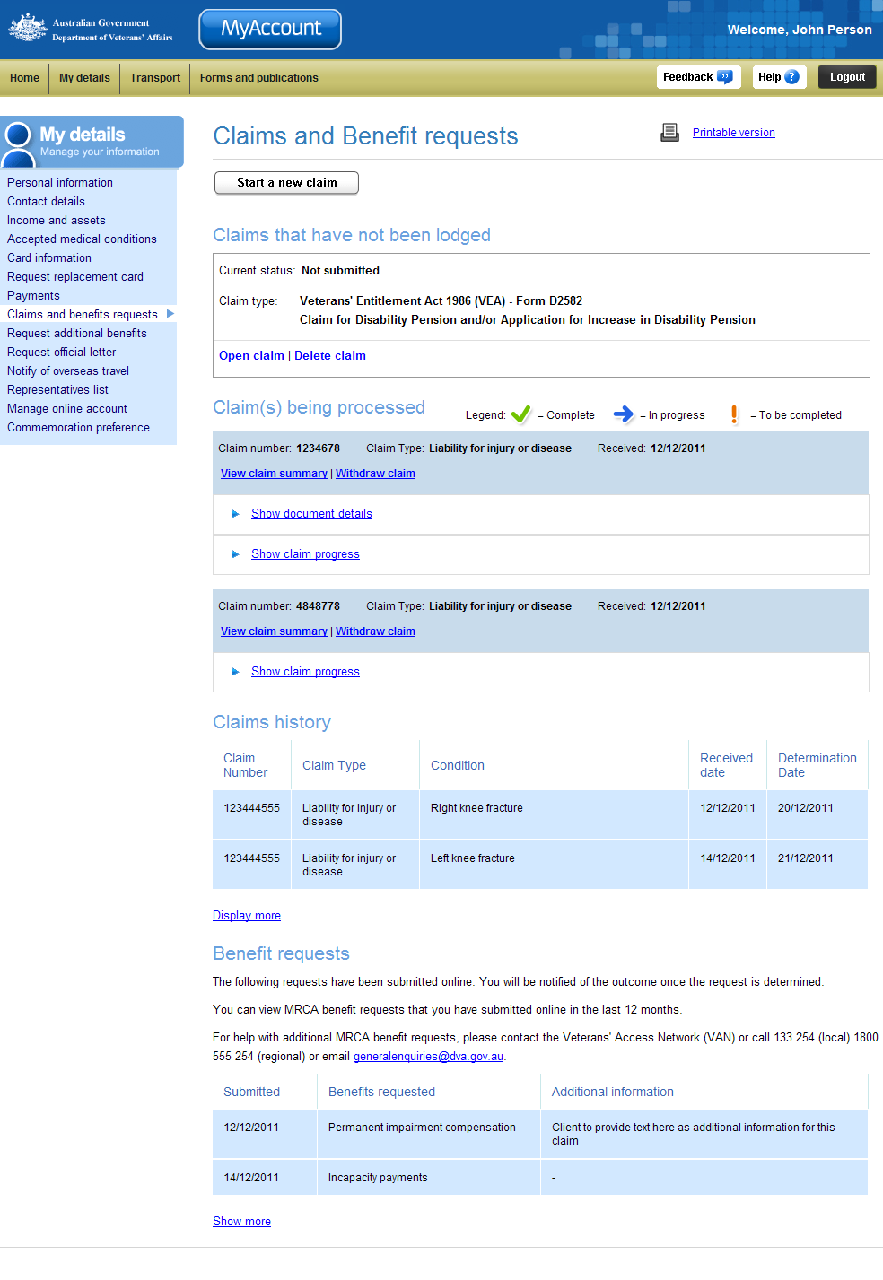
My details menu
Claims(s) being processed section
Claims that have not been lodged
Start a new claim
Claims history section
Benefit requests section

Online claim lodgement
Payments are available to compensate veterans, current and former serving members of the Australian Defence Force (ADF) for impairment and incapacity related to their Defence service.
The table below outlines the types of claim you can complete and lodge through MyAccount.
Claim type | Act | Form No. | Claim form name
Disability Pension | VEA | D2582 | Claim for Disability and/or Application for Increase in Disability Pension
Liability for Injury or disease | SRCA | D2020 | Claim for Rehabilitation and Compensation
Liability for Injury or disease | MRCA | D2051 | Claim for Liability and/or Reassessment of Compensation
Death Compensation | VEA | D2663 | Claim for Pension by a Widow, Widower or Other Dependant of a Deceased Veteran
Death Compensation | MRCA | D2053 | Claim for Compensation for Dependants of Deceased Members
Death Compensation | SRCA | D9182 | Claim for Compensation of Funeral Expenses and/or Death Benefits for Dependants of Deceased Members and Former Members of the ADF
Income Support related | - | D0506 | Claim to Determine Qualifying Service by a Current or Ex-member of the ADF
Income Support Pension related | - | D0503 | Claim for Service Pension
Income Support Pension related | - | D0504 | Claim for Service Pension by a Partner, Former Partner or Widow / Widower
Income Support Pension related | - | D0529 | Claim for Income Support Supplement
Income Support Pension related | - | D0664 | Claim for Transfer of Payment of Centrelink Age Pension to DVA
Income Support Card related | - | D3057 | Application for a Gold Card for Veterans of ADF
Income Support Card related | - | D3056 | Application for the Commonwealth Seniors Health Card

Parts of the online claim will be pre-populated with details you have already provided DVA including:
- personal details
- address details.
Claims lodged or determined prior to May 2012 are not displayed in MyAccount.

Claims that have not been lodged section
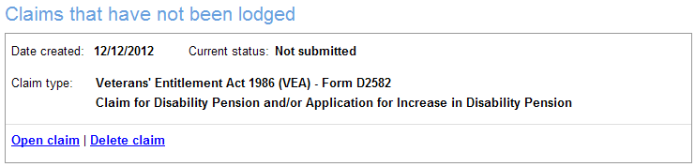
Date created and status
Open and delete claim
Claim type
From this screen you can view the status and type of a claim that has been started online but has not yet been lodged. You can open or delete this claim.
A draft claim is available to edit or delete for 3 months from when the claim was initially created.

Claims(s) being processed section
Claims which have not yet been determined are displayed in this section.
For claims lodged online you have the ability to withdraw the claim and view and attached additional documentation as required.
 | Progress for Initial Liability (SRCA, MRCA and VEA) and Death Compensation (SRCA, MRCA and VEA) claims submitted online can be tracked.  For each claim, a separate table displays information about the claim, including the stage the claim is at and the status of the claim within that stage.

After lodging a claim, it can take up to 5 days before the ‘Show claim progress’ is available.

The Claim(s) being processed section displays.
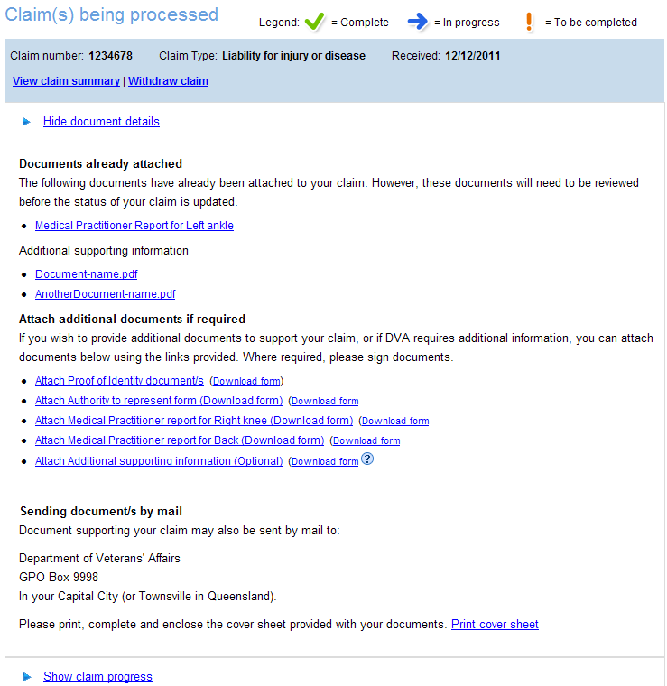
Claim details
Document details relating to the claim lodged online such as documents already attached and the ability to attach additional documents
View claim summary and withdraw claim
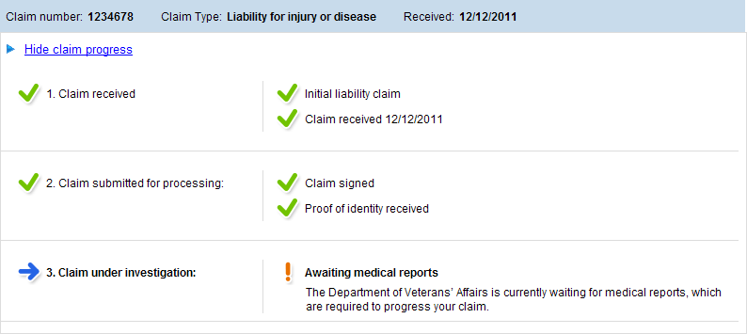
Claim progress
Claim status
At the top of the table, the claim status bar displays the:
- Claim number – the unique claim number
- Claim Type – one of 13 claim types listed above
- Received date – the date the claim was received by the department.
To show or hide a specific claim, at the top left of the claim table, select the Show claim progress or Hide claim progress link.

Claim stages and claim status
For each claim, the claim will progress through four stages:
- Claim received
- Claim submitted for processing
- Claim under investigation
- Claim determined.
The status of a claim and how far it has progressed is displayed visually by the stage the claim is at and the status of the claim within that stage. Claim progress is also represented by an icon.
Stage complete; document received; document signed; etc.
Processing in progress.
Awaiting status; awaiting documents; awaiting action; etc.

Claims history section
The Claims history section displays a list of all claims that have been completed within the last three years. This includes all claims determinated and claims withdrawn or merged with another claim.

The Claims history section.
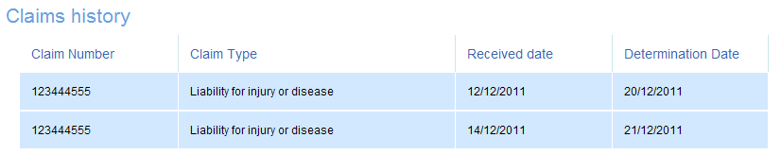
For each claim that has been completed, a separate line is displayed. The fields displayed are:
- Claim Number – the unique claim number
- Claim Type – one of 13 claim types
- Received date – the date the claim was received by the department
- Determination date – the date a decision was made on the claim, or alternatively, the date the claim was withdrawn or merged with another claim.

Benefit requests section
The Benefit requests section displays a list of any MRCA additional benefits requests submitted online, through MyAccount, in the last 12 months.

The Benefits requests section.
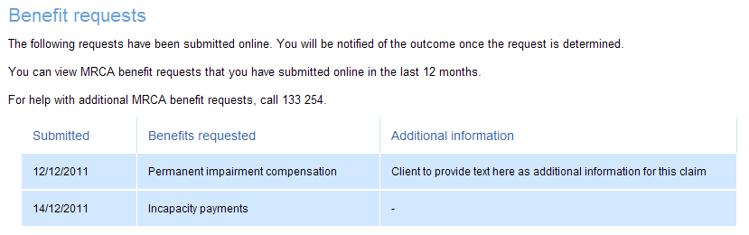
For each benefit request submitted, a separate line is displayed. The fields displayed are:
- Submitted – the date the request was submitted through MyAccount
- Benefits requested – the MRCA benefit that has been requested
- Additional information – any additional information provided at the time the request was submitted.

Other functions
 | To view another section and information from My details, click on a link in the My details menu to the left of the page.
 | To print a copy of the information displayed on this page, click on the Printable version link.
 | To get additional help with the Claims and Benefits requests screen, click on the Help button at to the top right of the page.
 | When you are finished using MyAccount, to log out and finish using the service in a secure way, click on the Logout button.

